## Reports/ Rx Reports/ Transfer Report

Request:

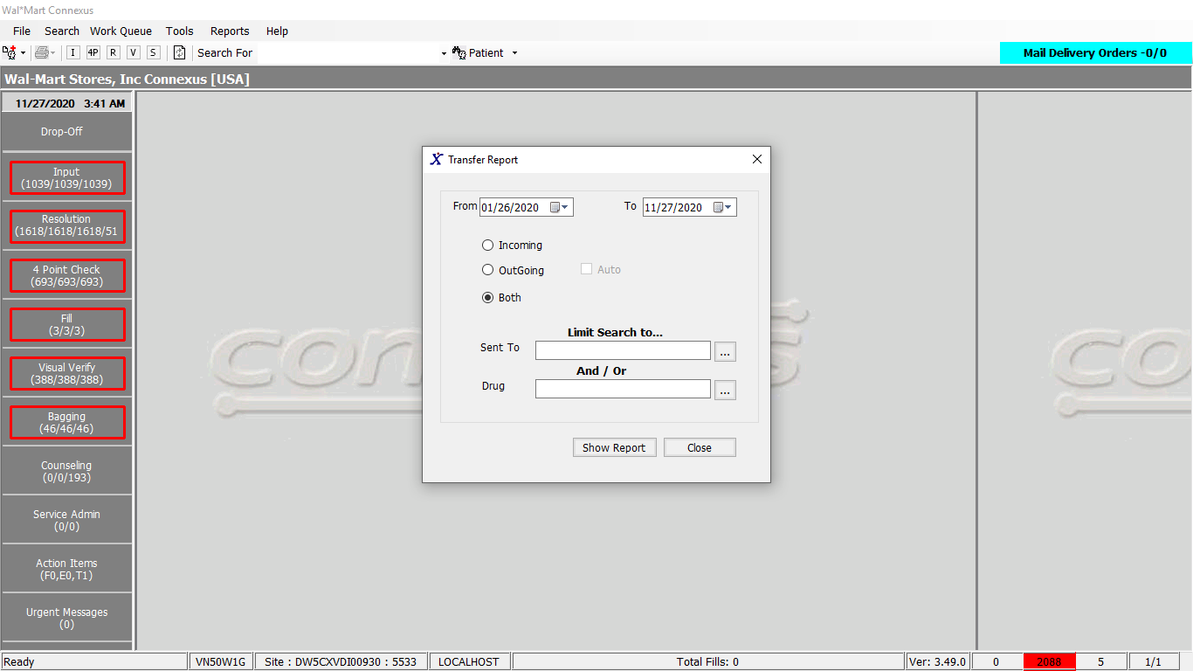

Response:

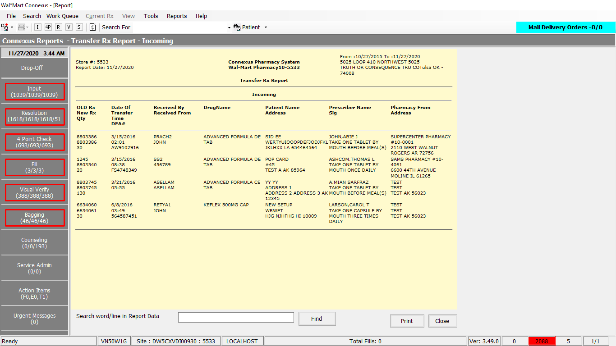

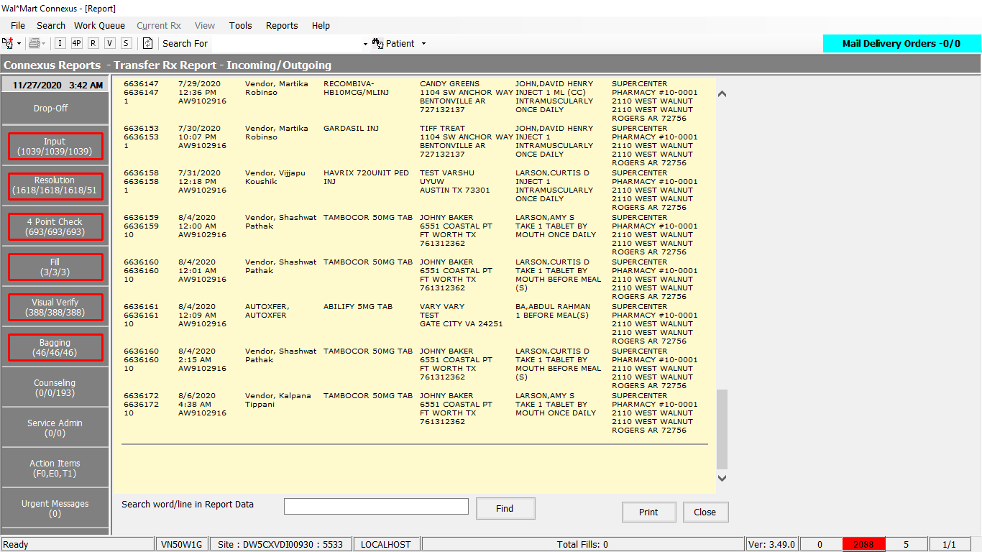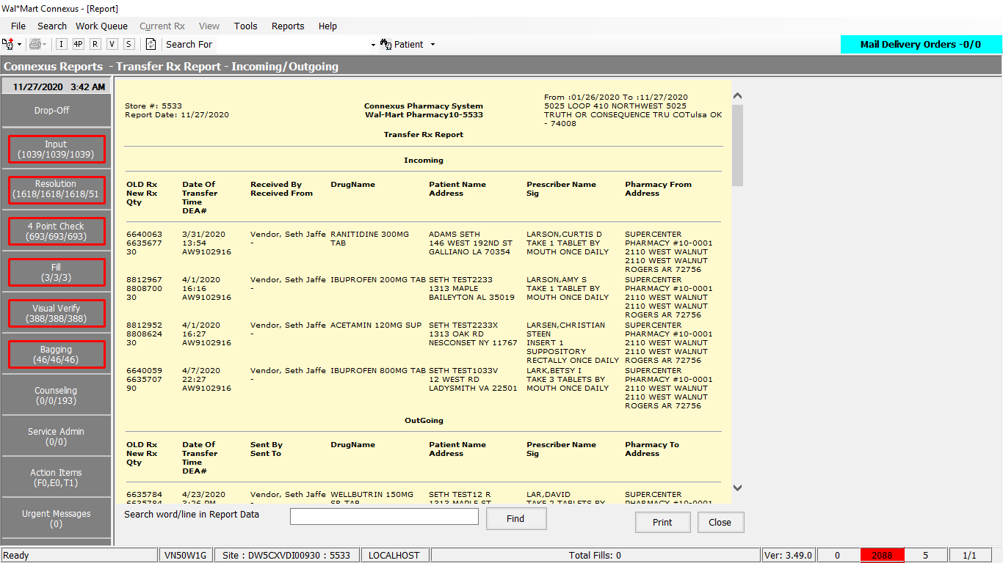

Query:

1. Friend Const GetStsTransferRptDataForTransferBoth As String = "SELECT rx.rx_id, rx.rx_version_seq_nbr, prt.transfer_rx_nbr original_rx_nbr, prt.create_ts tr_date, TRIM(NVL(prt.xfer_user_lst_name,'')) || ', ' || TRIM(NVL(prt.xfer_user_fst_name,'')) int_phm_userid, tpa.phm_name, tpa.phm_addr_line1, tpa.phm_addr_line2, tpa.phm_city_name, '' ext_rph_name, tpa.phm_state_cd, tpa.phm_postal_cd, tpa.phm_country_cd, tpa.phm_phone_nbr, tpa.phm_dea_nbr, tpa.phm_licence_nbr, pp.short_name, rx.rx_nbr, pa.last_name, pa.first_name,pa.middle_name,pa.birth_date, sc.communication_id Phone, sa.address_line_1, sa.address_line_2, sa.city_name,sa.state_prov_code,sa.postal_code, UPPER(TRIM(prt.transfer_in_ind)) xfer_in_ind, date(prt.create_ts) date_of_transfer,to_char(prt.create_ts,'%H:%M') time_of_transfer, TRIM(NVL(dr.last_name,'')) || ',' || TRIM(NVL(dr.first_name,'')) || ' ' || TRIM(NVL(dr.middle_name,'')) DRName, rx.fill_qty pres_qty, rx.expanded_sig_txt sig, rxt.expanded_sig_txt FROM phm_rx_transfer prt,transfer_phm_addr tpa, rx, patient pa, OUTER subject_address sa, OUTER subject_comm sc, pharmacy_offering:pharmacy_product pp, patient pat, prescriber dr, OUTER rx_text rxt WHERE prt.rx_id = rx.rx_id AND prt.transfer_stat_code= ? AND TRIM(tpa.xfer_phm_nbr)=CONCAT(prt.other_store_nbr,'') AND rx.patient_id = pat.patient_id AND rx.prescriber_id = dr.prescriber_id AND prt.rx_version_seq_nbr = rx.rx_version_seq_nbr AND rx.patient_id = pa.patient_id AND pa.patient_id = sa.subject_id AND sa.subject_type_code =? AND sa.addr_type_code = pa.dflt_addr_type_cd AND sc.subject_type_code = ? AND sc.comm_method_code = ? AND sc.comm_seq_nbr = ( case when pa.dflt_addr_type_cd = 3 then 1 else 10 end )AND pa.patient_id = sc.subject_id AND pp.product_mds_fam_id = rx.product_mds_fam_id AND rxt.rx_id = rx.rx_id"

2. Friend Const GetStsCmpndTransferRptDataForTransferBoth As String =

" SELECT rx.rx_id, rx.rx_version_seq_nbr, prt.transfer_rx_nbr original_rx_nbr, " &

" prt.create_ts tr_date, TRIM(NVL(prt.xfer_user_lst_name,'')) || ', ' || " &

" TRIM(NVL(prt.xfer_user_fst_name,'')) int_phm_userid, " &

" tpa.phm_name, tpa.phm_addr_line1, tpa.phm_addr_line2, tpa.phm_city_name, " &

" '' ext_rph_name, tpa.phm_state_cd, tpa.phm_postal_cd, tpa.phm_country_cd, " &

" tpa.phm_phone_nbr, tpa.phm_dea_nbr, tpa.phm_licence_nbr, " &

" co.compound_name short_name, rx.rx_nbr, pa.last_name, pa.first_name, " &

" pa.middle_name,pa.birth_date, sc.communication_id Phone, " &

" sa.address_line_1, sa.address_line_2, sa.city_name, " &

" sa.state_prov_code,sa.postal_code, UPPER(TRIM(prt.transfer_in_ind)) xfer_in_ind, " &

" date(prt.create_ts) date_of_transfer,to_char(prt.create_ts,'%H:%M') time_of_transfer, " &

" TRIM(NVL(dr.last_name,'')) || ',' || TRIM(NVL(dr.first_name,'')) || " &

" ' ' || TRIM(NVL(dr.middle_name,'')) DRName, rx.fill_qty pres_qty, " &

" rx.expanded_sig_txt sig, rxt.expanded_sig_txt " &

" FROM phm_rx_transfer prt,transfer_phm_addr tpa, rx, " &

" patient pa, OUTER subject_address sa, OUTER subject_comm sc, " &

" rx_compound rc, compound co, patient pat, " &

" prescriber dr, OUTER rx_text rxt " &

" WHERE prt.rx_id = rx.rx_id " &

" AND prt.transfer_stat_code= {0} " &

" AND TRIM(tpa.xfer_phm_nbr)=CONCAT(prt.other_store_nbr,'') " &

" AND rx.patient_id = pat.patient_id " &

" AND rx.prescriber_id = dr.prescriber_id " &

" AND prt.rx_version_seq_nbr = rx.rx_version_seq_nbr " &

" AND rx.patient_id = pa.patient_id " &

" AND pa.patient_id = sa.subject_id " &

" AND sa.subject_type_code ={1} " &

" AND sa.addr_type_code = pa.dflt_addr_type_cd " &

" AND sc.subject_type_code = {2} " &

" AND sc.comm_method_code = {3} " &

" AND sc.comm_seq_nbr = ( case when pa.dflt_addr_type_cd = 3 then 1 else 10 end) " &

" AND pa.patient_id = sc.subject_id " &

" AND co.compound_id = rc.compound_id " &

" AND rc.rx_id = rx.rx_id " &

" AND rc.rx_version_seq_nbr = rx.rx_version_seq_nbr " &

" AND rxt.rx_id = rx.rx_id "

3. Friend Const GetStsTransferRptData As String = " SELECT rx.rx_id, rx.rx_version_seq_nbr, rt.original_rx_nbr, rt.transfer_ts tr_date, rt.int_phm_userid, rt.phm_name, rt.phm_addr_line1, rt.phm_addr_line2, rt.phm_city_name, rt.ext_rph_name, rt.phm_state_cd, rt.phm_postal_cd, rt.phm_country_cd, rt.phm_phone_nbr, rt.phm_dea_nbr, rt.phm_licence_nbr, pp.short_name, rx.rx_nbr, pa.last_name, pa.first_name,pa.middle_name,pa.birth_date, sc.communication_id Phone, sa.address_line_1, sa.address_line_2, sa.city_name,sa.state_prov_code,sa.postal_code, UPPER(TRIM(rt.xfer_in_ind)) xfer_in_ind, date(rt.transfer_ts) date_of_transfer,to_char(rt.transfer_ts,'%H:%M') time_of_transfer, TRIM(NVL(dr.last_name,'')) || ',' || TRIM(NVL(dr.first_name,'')) || ' ' || TRIM(NVL(dr.middle_name,'')) DRName, rx.fill_qty pres_qty, rx.expanded_sig_txt sig, rxt.expanded_sig_txt FROM rx_transfer rt, rx, patient pa, OUTER subject_address sa, OUTER subject_comm sc, OUTER rx_text rxt, pharmacy_offering:pharmacy_product pp, patient pat, prescriber dr WHERE rt.rx_id = rx.rx_id AND rx.patient_id = pat.patient_id AND rx.prescriber_id = dr.prescriber_id AND rt.rx_version_seq_nbr = rx.rx_version_seq_nbr AND rx.patient_id = pa.patient_id AND pa.patient_id = sa.subject_id AND sa.subject_type_code = ? AND sa.addr_type_code = pa.dflt_addr_type_cd AND sc.subject_type_code = ? AND sc.comm_method_code = ? AND sc.comm_seq_nbr = ( case when pa.dflt_addr_type_cd = 3 then 1 else 10 end ) AND pa.patient_id = sc.subject_id AND pp.product_mds_fam_id = rx.product_mds_fam_id AND rxt.rx_id = rx.rx_id"

4. Friend Const GetStsCmpndTransferRptData As String =

" SELECT rx.rx_id, rx.rx_version_seq_nbr, rt.original_rx_nbr, " &

" rt.transfer_ts tr_date, rt.int_phm_userid, rt.phm_name,rt.phm_addr_line1, " &

" rt.phm_addr_line2, rt.phm_city_name, rt.ext_rph_name, rt.phm_state_cd, " &

" rt.phm_postal_cd, rt.phm_country_cd, rt.phm_phone_nbr, rt.phm_dea_nbr, " &

" rt.phm_licence_nbr, co.compound_name short_name, rx.rx_nbr, pa.last_name, " &

" pa.first_name,pa.middle_name,pa.birth_date, sc.communication_id Phone,sa.address_line_1, " &

" sa.address_line_2, sa.city_name,sa.state_prov_code,sa.postal_code, " &

" UPPER(TRIM(rt.xfer_in_ind)) xfer_in_ind,date(rt.transfer_ts) date_of_transfer, " &

" to_char(rt.transfer_ts,'%H:%M') time_of_transfer, " &

" TRIM(NVL(dr.last_name,'')) || ',' || TRIM(NVL(dr.first_name,'')) || " &

" ' ' || TRIM(NVL(dr.middle_name,'')) DRName, " &

" rx.fill_qty pres_qty, rx.expanded_sig_txt sig, rxt.expanded_sig_txt " &

" FROM rx_transfer rt, rx, patient pa, OUTER subject_address sa, " &

" OUTER subject_comm sc, OUTER rx_text rxt, compound co, " &

" patient pat, prescriber dr, rx_compound rc " &

" WHERE rt.rx_id = rx.rx_id " &

" AND rx.patient_id = pat.patient_id " &

" AND rx.prescriber_id = dr.prescriber_id " &

" AND rt.rx_version_seq_nbr = rx.rx_version_seq_nbr " &

" AND rx.patient_id = pa.patient_id " &

" AND pa.patient_id = sa.subject_id " &

" AND sa.subject_type_code = {0} " &

" AND sa.addr_type_code = pa.dflt_addr_type_cd " &

" AND sc.subject_type_code = {1} " &

" AND sc.comm_method_code = {2} " &

" AND sc.comm_seq_nbr = ( case when pa.dflt_addr_type_cd = 3 then 1 else 10 end ) " &

" AND pa.patient_id = sc.subject_id " &

" AND co.compound_id = rc.compound_id " &

" AND rc.rx_id = rx.rx_id " &

" AND rc.rx_version_seq_nbr = rx.rx_version_seq_nbr " &

" AND rxt.rx_id = rx.rx_id "

Dal:

Public Function GetStsTransferRptData(ByVal siteId As Integer,

ByVal getStsTransferRptDataInputInfo As _

GetStsTransferRptDataInputInfoBE) As _

List(Of GetStsTransferRptDataInfoBE) Implements IReportDAL.GetStsTransferRptData

Using (New Tracer(ConnexusCommonConstants.ConnexusTracer))

Dim sqlString As New StringBuilder

Dim sqlCmpndString As New StringBuilder

Dim transferQuery As New StringBuilder

Dim transferCmpndQuery As New StringBuilder

Dim paramList As New List(Of DbParameter)

Dim getSTSTransferRptDataList As New List(Of GetStsTransferRptDataInfoBE)

If getStsTransferRptDataInputInfo IsNot Nothing Then

If getStsTransferRptDataInputInfo.RptLayout = ServicesCommonConstants.TransferAuto Or getStsTransferRptDataInputInfo.RptOption = ServicesCommonConstants.TransferBoth Then

sqlString.Append(ReportQueries.GetStsTransferRptDataForTransferBoth)

paramList.AddParameter(DbType.Int32, TransferStatus.TransferComplete, "TransferComplete")

paramList.AddParameter(DbType.Int32, SubjectTypeCode.Patient, "SubjPat")

paramList.AddParameter(DbType.Int32, SubjectTypeCode.Patient, "SubjPat")

paramList.AddParameter(DbType.Int32, ServicesCommonConstants.CommMethodPhone, "CommonMethodCode")

'Adding for compounds query -- Sunil 03/30/2010

sqlCmpndString.Remove(0, sqlCmpndString.Length)

sqlCmpndString.AppendFormat(ReportQueries.GetStsCmpndTransferRptDataForTransferBoth,

Convert.ToInt32(TransferStatus.TransferComplete),

SubjectTypeCode.Patient + 0,

SubjectTypeCode.Patient + 0,

ServicesCommonConstants.CommMethodPhone)

If getStsTransferRptDataInputInfo.StartDate <> CDate(Nothing) AndAlso getStsTransferRptDataInputInfo.EndDate <> CDate(Nothing) Then

sqlString.Append(" AND DATE(prt.create_ts) >= ? ")

paramList.AddParameter(DbType.Date, getStsTransferRptDataInputInfo.StartDate, "CreateStartDate")

sqlString.Append(" AND DATE(prt.create_ts) <= ? ")

paramList.AddParameter(DbType.Date, getStsTransferRptDataInputInfo.EndDate, "CreateEndDate")

'Adding for compounds query -- Sunil 03/30/2010

sqlCmpndString.AppendFormat(" AND DATE(prt.create_ts) between '{0}' and '{1}' ",

getStsTransferRptDataInputInfo.StartDate.ToShortDateString,

getStsTransferRptDataInputInfo.EndDate.ToShortDateString)

End If

If getStsTransferRptDataInputInfo.RptOption = ServicesCommonConstants.TransferOutgoing Then

sqlString.Append(" AND prt.transfer_in_ind= 'N'")

'Adding for compounds query -- Sunil 03/30/2010

sqlCmpndString.Append(" AND prt.transfer_in_ind= 'N'")

ElseIf getStsTransferRptDataInputInfo.RptOption = ServicesCommonConstants.TransferIncoming Then

sqlString.Append(" AND prt.transfer_in_ind= 'Y'")

'Adding for compounds query -- Sunil 03/30/2010

sqlCmpndString.Append(" AND prt.transfer_in_ind= 'Y'")

End If

If Not getStsTransferRptDataInputInfo.SentTo Is Nothing AndAlso getStsTransferRptDataInputInfo.SentTo.Trim.Length > 0 Then ' pharmacy name

sqlString.Append(" AND UPPER(TRIM(tpa.phm_name)) LIKE '" & getStsTransferRptDataInputInfo.SentTo.Trim.ToUpper(CultureInfo.InvariantCulture).Replace("'", "''") & "%'")

'Adding for compounds query -- Sunil 03/30/2010

sqlCmpndString.Append(" AND UPPER(TRIM(tpa.phm_name)) LIKE '" & getStsTransferRptDataInputInfo.SentTo.Trim.ToUpper(CultureInfo.InvariantCulture).Replace("'", "''") & "%'")

End If

If getStsTransferRptDataInputInfo.ProductId > 0 Then ' product mds fam id

sqlString.Append(" AND rx.product_mds_fam_id= ? ")

paramList.Add(ParameterHelper.BuildParameter("ProductMdsId", DbType.Int32, getStsTransferRptDataInputInfo.ProductId))

'Adding for compounds query -- Sunil 03/30/2010

sqlCmpndString.AppendFormat(" AND rx.product_mds_fam_id= {0} ", getStsTransferRptDataInputInfo.ProductId)

End If

End If

End If

' regular transfer query

transferQuery.Append(ReportQueries.GetStsTransferRptData)

paramList.AddParameter(DbType.Int32, SubjectTypeCode.Patient, "SubjPat")

paramList.AddParameter(DbType.Int32, SubjectTypeCode.Patient, "SubjPat")

paramList.AddParameter(DbType.Int32, ServicesCommonConstants.CommMethodPhone, "CommonMethodCode")

'Adding for compounds query -- Sunil 03/30/2010

transferCmpndQuery.Remove(0, transferCmpndQuery.Length)

transferCmpndQuery.AppendFormat(ReportQueries.GetStsCmpndTransferRptData,

SubjectTypeCode.Patient + 0,

SubjectTypeCode.Patient + 0,

ServicesCommonConstants.CommMethodPhone)

If Not getStsTransferRptDataInputInfo Is Nothing Then

If getStsTransferRptDataInputInfo.StartDate <> CDate(Nothing) And getStsTransferRptDataInputInfo.EndDate <> CDate(Nothing) Then

transferQuery.Append(" AND DATE(rt.transfer_ts) >= ? ")

paramList.AddParameter(DbType.Date, getStsTransferRptDataInputInfo.StartDate, "CreateStartDate")

transferQuery.Append(" AND DATE(rt.transfer_ts) <= ? ")

paramList.AddParameter(DbType.Date, getStsTransferRptDataInputInfo.EndDate, "Createnddate")

'Adding for compounds query -- Sunil 03/30/2010

transferCmpndQuery.AppendFormat(" AND DATE(rt.transfer_ts) between '{0}' and '{1}' ",

getStsTransferRptDataInputInfo.StartDate.ToShortDateString,

getStsTransferRptDataInputInfo.EndDate.ToShortDateString)

End If

If getStsTransferRptDataInputInfo.RptOption = ServicesCommonConstants.TransferOutgoing Then

transferQuery.Append(" AND rt.xfer_in_ind = 'N'")

'Adding for compounds query -- Sunil 03/30/2010

transferCmpndQuery.Append(" AND rt.xfer_in_ind = 'N'")

ElseIf getStsTransferRptDataInputInfo.RptOption = ServicesCommonConstants.TransferIncoming Then

transferQuery.Append(" AND rt.xfer_in_ind = 'Y'")

'Adding for compounds query -- Sunil 03/30/2010

transferCmpndQuery.Append(" AND rt.xfer_in_ind = 'Y'")

End If

If getStsTransferRptDataInputInfo.RptLayout = ServicesCommonConstants.TransferAuto Then

transferQuery.Append(" AND rt.auto_transfer_ind = 'Y'")

'Adding for compounds query -- Sunil 03/30/2010

transferCmpndQuery.Append(" AND rt.auto_transfer_ind = 'Y'")

ElseIf getStsTransferRptDataInputInfo.RptLayout = ServicesCommonConstants.TransferManual Then

transferQuery.Append(" AND rt.auto_transfer_ind = 'N'")

'Adding for compounds query -- Sunil 03/30/2010

transferCmpndQuery.Append(" AND rt.auto_transfer_ind = 'N'")

End If

If Not getStsTransferRptDataInputInfo.SentTo Is Nothing AndAlso getStsTransferRptDataInputInfo.SentTo.Trim.Length > 0 Then ' pharmacy name

transferQuery.Append(" AND UPPER(TRIM(rt.phm_name)) LIKE '" & getStsTransferRptDataInputInfo.SentTo.Trim.ToUpper(CultureInfo.InvariantCulture).Replace("'", "''") & "%'")

'Adding for compounds query -- Sunil 03/30/2010

transferCmpndQuery.Append(" AND UPPER(TRIM(rt.phm_name)) LIKE '" & getStsTransferRptDataInputInfo.SentTo.Trim.ToUpper(CultureInfo.InvariantCulture).Replace("'", "''") & "%'")

End If

If getStsTransferRptDataInputInfo.ProductId > 0 Then ' product mds fam id

transferQuery.Append(" AND rx.product_mds_fam_id= ? ")

paramList.AddParameter(DbType.Int32, getStsTransferRptDataInputInfo.ProductId, "ProductMdsId")

'Adding for compounds query -- Sunil 03/30/2010

transferCmpndQuery.AppendFormat(" AND rx.product_mds_fam_id= {0} ", getStsTransferRptDataInputInfo.ProductId)

End If

' if it's AUTOTRANSFER, then only we need to include the STS; otherwise, it's just regular transfer report

End If

If getStsTransferRptDataInputInfo.RptLayout = ServicesCommonConstants.TransferAuto Or getStsTransferRptDataInputInfo.RptOption = ServicesCommonConstants.TransferBoth Then

sqlString.Append(" UNION ")

sqlString.Append(transferQuery)

'Adding for compounds query -- Sunil 03/30/2010

sqlString.Append(" UNION ")

sqlString.Append(sqlCmpndString)

sqlString.Append(" UNION ")

sqlString.Append(transferCmpndQuery)

Else

sqlString = transferQuery

'Adding for compounds query -- Sunil 03/30/2010

sqlString.Append(" UNION ")

sqlString.Append(transferCmpndQuery)

End If

'Changes End -- Sunil 03/30/2010

sqlString.Append(" ORDER BY 4;") ' transfer date

Dim dataReader As IDataReader = ExecuteReader(DatabaseEnum.rx21c, siteId, sqlString.ToString, paramList)

Dim getSTSTransferRptDataBE As GetStsTransferRptDataInfoBE

While dataReader.Read

getSTSTransferRptDataBE = New GetStsTransferRptDataInfoBE

getSTSTransferRptDataBE.AddressLine1 = (dataReader.GetValueOrDefault(Of String)("address_line_1")).SafeTrim()

getSTSTransferRptDataBE.AddressLine2 = (dataReader.GetValueOrDefault(Of String)("address_line_2")).SafeTrim()

getSTSTransferRptDataBE.BirthDate = (dataReader.GetValueOrDefault(Of Date)("birth_date"))

getSTSTransferRptDataBE.CityName = (dataReader.GetValueOrDefault(Of String)("city_name")).SafeTrim()

getSTSTransferRptDataBE.DateOfTransfer = (dataReader.GetValueOrDefault(Of Date)("date_of_transfer"))

getSTSTransferRptDataBE.DoctorName = (dataReader.GetValueOrDefault(Of String)("DRName")).SafeTrim()

getSTSTransferRptDataBE.ExtRphName = (dataReader.GetValueOrDefault(Of String)("ext_rph_name")).SafeTrim()

getSTSTransferRptDataBE.FirstName = (dataReader.GetValueOrDefault(Of String)("first_name")).SafeTrim()

getSTSTransferRptDataBE.IntPhmUserId = (dataReader.GetValueOrDefault(Of String)("int_phm_userid")).SafeTrim()

getSTSTransferRptDataBE.LastName = (dataReader.GetValueOrDefault(Of String)("last_name")).SafeTrim()

getSTSTransferRptDataBE.MiddleName = (dataReader.GetValueOrDefault(Of String)("middle_name")).SafeTrim()

getSTSTransferRptDataBE.OriginalRxNbr = (dataReader.GetValueOrDefault(Of Int32)("original_rx_nbr"))

getSTSTransferRptDataBE.PhmAddrLine1 = (dataReader.GetValueOrDefault(Of String)("phm_addr_line1")).SafeTrim()

getSTSTransferRptDataBE.PhmAddrLine2 = (dataReader.GetValueOrDefault(Of String)("phm_addr_line2")).SafeTrim()

getSTSTransferRptDataBE.PhmCityName = (dataReader.GetValueOrDefault(Of String)("phm_city_name")).SafeTrim()

getSTSTransferRptDataBE.PhmCountryCd = (dataReader.GetValueOrDefault(Of String)("phm_country_cd")).SafeTrim()

getSTSTransferRptDataBE.PhmDeaNbr = (dataReader.GetValueOrDefault(Of String)("phm_dea_nbr")).SafeTrim()

getSTSTransferRptDataBE.PhmLicenseNbr = (dataReader.GetValueOrDefault(Of String)("phm_licence_nbr")).SafeTrim()

getSTSTransferRptDataBE.PhmName = (dataReader.GetValueOrDefault(Of String)("phm_name")).SafeTrim()

getSTSTransferRptDataBE.PhmPhoneNbr = (dataReader.GetValueOrDefault(Of String)("phm_phone_nbr")).SafeTrim()

getSTSTransferRptDataBE.PhmPostalCd = (dataReader.GetValueOrDefault(Of String)("phm_postal_cd")).SafeTrim()

getSTSTransferRptDataBE.PhmStateCd = (dataReader.GetValueOrDefault(Of String)("phm_state_cd")).SafeTrim()

getSTSTransferRptDataBE.Phone = (dataReader.GetValueOrDefault(Of String)("Phone")).SafeTrim()

getSTSTransferRptDataBE.PostalCode = (dataReader.GetValueOrDefault(Of String)("postal_code")).SafeTrim()

getSTSTransferRptDataBE.PresQty = CInt(dataReader.GetValueOrDefault(Of Decimal)("pres_qty"))

getSTSTransferRptDataBE.RxId = (dataReader.GetValueOrDefault(Of Int32)("rx_id"))

getSTSTransferRptDataBE.RxNbr = (dataReader.GetValueOrDefault(Of Int32)("rx_nbr"))

getSTSTransferRptDataBE.RxVersionSeqNbr = (dataReader.GetValueOrDefault(Of Int16)("rx_version_seq_nbr"))

getSTSTransferRptDataBE.ShortName = (dataReader.GetValueOrDefault(Of String)("short_name")).SafeTrim()

getSTSTransferRptDataBE.Signature = (dataReader.GetValueOrDefault(Of String)("sig")).SafeTrim()

getSTSTransferRptDataBE.PhmName = (dataReader.GetValueOrDefault(Of String)("phm_name")).SafeTrim()

getSTSTransferRptDataBE.StateProvCode = (dataReader.GetValueOrDefault(Of String)("state_prov_code")).SafeTrim()

getSTSTransferRptDataBE.TimeOfTransfer = CDate(dataReader.GetValueOrDefault(Of String)("time_of_transfer"))

getSTSTransferRptDataBE.TransferDate = CDate(dataReader.GetValueOrDefault(Of DateTime)("tr_date"))

getSTSTransferRptDataBE.XferInInd = (dataReader.GetValueOrDefault(Of String)("xfer_in_ind")).SafeTrim()

getSTSTransferRptDataBE.ExpandedSig = (dataReader.GetValueOrDefault(Of String)("expanded_sig_txt")).SafeTrim()

getSTSTransferRptDataList.Add(getSTSTransferRptDataBE)

End While

If getSTSTransferRptDataList.Count > 0 Then

Return getSTSTransferRptDataList

Else

Return Nothing

End If

End Using

End Function